

## Augmented Reality start-up uses Ethereum ICO to excite Blockchain investors

Assistive Reality is an Australian start-up project created by a team of information and biotechnology professionals with experience in AI systems, user interface design, 3D modelling and a driving interest in human-augmentation technology.

* *The name Assistive Reality is derived from our concept of creating applications that will use intelligent AI systems from a variety of authors, to integrate with device sensors, and cloud-computing to provide assistance to the human wearer in their professional and home life.*

Assistive Reality is an Augmented Reality applications developer with a speciality in providing integrated Artificial Intelligence for the AR experience. These AIs can be configured to provide differing levels of human-assist, from full audio/visual task guidance to simple memory/reminder tasks. Since the AI has access to the input from the AR headset sensors, it literally is able to put itself in the position of the wearer and see exactly the perspective required.

aronline.io is the website for Assistive Reality, and will be the basis for delivering user profiles, dynamic applications and Blockchain-integrated services such as interacting with the license redemption smart contract (Exchange ARX for licenses, or ARX for download code to native device store) or for retrieving and updating biometric ID prints stored on the Blockchain.

If successfully funded Assistive Reality will be positioned to successfully hit the Quarter 2 of 2018 milestone for release of two Augmented Reality applications via each device’s store:

1. World 1, and
2. Profession

These applications will be built on Assistive Reality’s commercial-grade Spectrum AR engine, natively compiled and customised for each device to obtain maximum performance.

World 1 introduces the concept of an AR World Browser, allowing an always-on AR experience whether at home or in public, with seeded content and a fully integrated AI offering configurable levels of assistance. Additionally, in this multi-platform, multi-user networked world, users that hold ARX tokens gain the ability to host AR zones for grouped interaction such as world-scale gaming, choose-your-own-adventure style role playing, or team challenges.

Profession is intended for light-to-medium professional usage, and allows the user to select a job role or task function; the inbuilt AI is more comprehensive than even in World 1, and will observe the environment through 3D positional tracking and offer visual cues and guidance specific to that task. The task database is built up by a learning algorithm that aims to continually improve its success rate. Profession is intended to directly augment a human’s ability to perform their normal job function, and will be actively monitored to ensure the relevant features most-used are given the most prominence and best integration within the app.

One of the important functions of our Spectrum AR’s API is access to the Ethereum Blockchain; this provides a number of features such as secure storage of biometric ID hashes, data hash storage and replication, AR zone funding/rewards payouts via smart contract, license purchase/tracking, in-world and experience currency for purchases, low cost high availability replication through combination of public/private eth chains, ARX token issuance for inbuilt ERC20 token trading and lastly, the ability for Assistive Reality world designers to configure various points in the real world with actual Ethereum smart contracts behind them, to trigger events as and when time points elapse or users approach them.

We believe World 1 will excite people in a way similar to Pokemon Go but with a far wider-reaching commercial potential and without any of the single-platform entry requirements of almost all other similar products.

From a **commercial** standpoint, we have a fully developed business and marketing plan, and intend to approach revenue development from a number of angles. We have strong projections within the corporate AR/MR space as Spectrum provides highly advanced enterprise-integration (Office 365, AWS, Microsoft and Unix stacks), it can be readily adopted to almost any major corporation’s workflow, and its highly robust 3D object recognition capabilities enable a variety of usage cases.

Crucial to the project’s later financial viability is our enterprise market penetration and home/public user numbers. To this end, all members of our team have strong experience building and nurturing relationships with government, defence and corporate organisations, whilst also being avid consumers of early and advanced technology themselves. We will leverage our wide-ranging contact base and a significant marketing spend across Asia-Pacific and China to gain early trials and secure demand for our AR/MR applications. To improve enterprise integration options we’ve architected features such as cloud (Office 365, AWS) and local Directory Service integration, OS policy enforcement, Blockchain secured biometrics and building-system/home-bot integration.

Our plans for Augmentation technology are not limited to optical headsets; we are also actively researching and creating software prototypes to implement building-wide AR environments, and creating partnerships within the optics industry, with the goal of deploying code to run on contact lens or implant technology systems as and when they become available.

## What are the aims of the project?

**Mission goals**

* Champion the integration of Artificial Intelligence software with Augmented Reality devices
* Enable humans to be highly competitive in complex tasks where AI has an inherent advantage
* Act as a catalyst for the adoption of AR/MR/VR technology in business
* Increase commercial awareness and adoption of the Ethereum Blockchain & smart contracts
* Provide an example of ICO fundraising bootstrapping a successful Tier 1 technology firm
* Establish relationships within the contact lens design and production industry

**Deployment goals**

* Complete development and compatibility testing of our Spectrum Augmented Reality engine
* Contract to deploy 15 Spectrum application sites within 2018
* Ensure our Spectrum-based Profession apps reach top 10 rank/major app stores within 2019
* Ensure our World 1 world browser reaches top 10 rank/major app stores within 2019

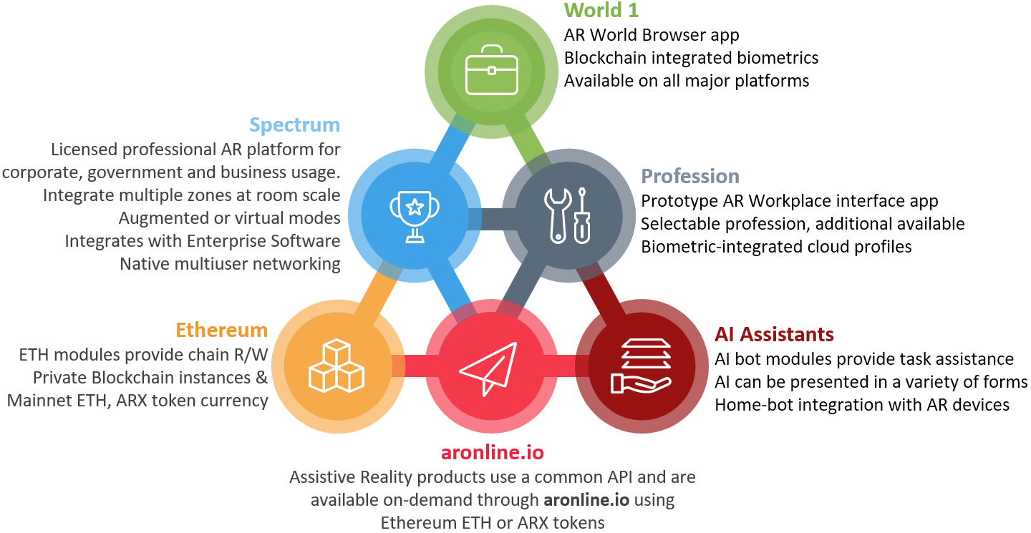

What is the timeline?

In the first 24 months we are aiming to establish the Australian division of the company **Assistive Reality** to facilitate research, development, deployment, demonstrations and licensing; we have also committed to a number of foundation site clients and interested parties to deliver the following clear outcomes by our March 2019 “**Deploy**” milestone:

* Perform ICO (**ARX** token), fund company structure, establish development contracts
* Demonstrate Spectrum alpha software running with sample tasks at various trade events
* License 5 Foundation Sites for Spectrum deployment trials in early 2018, ramping up to 15
* Release Spectrum beta to foundation sites, monitor and adjust onsite
* Release World 1 beta World Browser for Google AR, Glass, Microsoft AR/MR and Apple AR
* Perform World 1 closed alpha test of large-scale multiuser networking
* Deploy Ethereum smart contract to public main net for exchanging **ARX** tokens for World 1 access or Spectrum licenses
* Begin advanced AI-in-AR research paper regarding in-world and in-zone automation
* Publish a research paper discussing the future-state of human visual augmentation
* Scale development up to 3 full-time development team members
* Test private Ethereum Blockchain secure-storage smart contract functions

We have segmented and summarised some milestones from the first 4 years of operation into clear **Startup, Disrupt, Deploy** and **Scale** phases, as shown below:

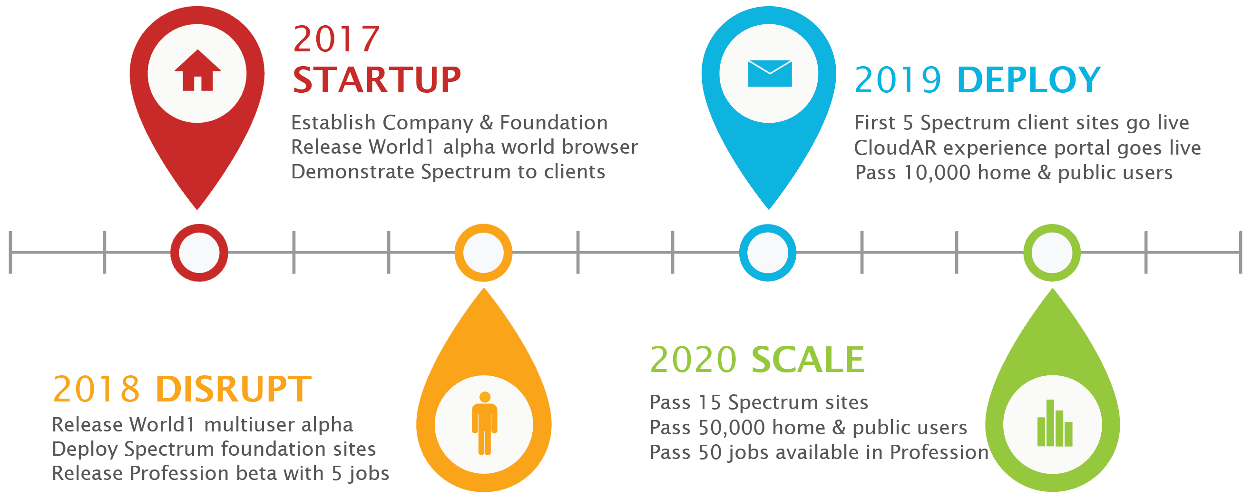

## Why is Ethereum integration important?

Ethereum is a leading cryptocurrency in 2017 and has many advanced features including Turing-complete smart contract scripting and sandboxed code execution. Ethereum’s EVM programmability has contributed to the rise of many distributed applications and offers unique integration options for AR/MR applications. Building our software with native support for Ethereum technology provides the following benefits for our users:

* Private or Public Blockchain-secured Biometrics for each user provide security, audit trail, and data survivability with integrity beyond a typical private database
* Swarm technology is leveraged for roaming user data and some profile information
* Smart contracts are executed using distributed computing (nodes) allowing a degree of processing-offload for miniaturised devices
* Ethereum configurations are already available within major cloud provider services, giving immediate, well-understood scaling when storing data for enterprise client solutions
* Ethereum has a strong development roadmap and community, with good leadership, which has led to widespread trust and adoption across a range of platforms, by a variety of internationally-respected companies; integrating with Ethereum allows us to work with a proven community of professionals with established toolsets and practices, increasing consistency and standardisation
* **ARX** tokens issued in our ICO can be exchanged using the redemption smart contract for World 1 and Profession early access
* **ARX** tokens and ETH can be used to interact with paid content in all Assistive Reality consumer-facing applications, including AR zones that contain premium content
* Ethereum’s developer community will be directly leveraged to hire coders and testers for smart contracts and Blockchain integration when building World Zones and assistive AI Bots
* As an early developer and integrator, Assistive Reality aims to gain significant market share within Government, Defence and Corporate organisations, exposing them to Ethereum technology potentially for the first time, expanding the reach of Ethereum in general

## What is our vision for corporate or government users?

We envisage high end usage of Augmented Reality to occur at a large scale; car production factories, construction projects, law enforcement, education and health care are all examples of sectors that can benefit enormously from intelligent augmentation software solutions.

For corporate users, we provide two options during 2018/2019;

1. Engage with us to plan a custom-built application/suite based on our bespoke Spectrum platform with onsite hardware integration, AR/MR zones, room-scale VR facilities, Ethereum Blockchain integration. This option is recommended for larger companies who have significant facilities or high staff numbers. The following diagram shows the engagement process for a partner company who desires a customised commercial-grade Augmented Reality/Mixed Reality solution
2. Purchase the Profession application from the app store on your device; this is our prebuilt user-customisable application. Profession is recommended for smaller companies or other users that may be performing a work activity and is available with alternative UIs and a selectable list of professions.

Profession features include:

* Switchable user interface (for different job roles, or preferences)
* Professions to select will be added regularly
* Surface-to-screen projection
* AI-bot or Virtual Assistant
* Fine-tuned UI/UX for each profession type
* Guided Action with prompting
* Real-time Communications
* App integration
* Blockchain Recording and Archiving
* Room and Dimensional-space scaling

## What problem does this project solve?

Augmented and Mixed Reality environments represent an important juncture for computing system interface design; this project aims to solve many basic problems with AR/MR/VR technology adoption in the home and Enterprise, including:

* **Problem:** AI is capable of outperforming humans in various tasks (such as demonstrated in complex challenges: Deep Blue Chess, alphaGo, openAI). This extends to the future workplace and possible future of the robotics industry.  
  **Our solution (or rather, our roadmap to the solution):** Augment the Human experience using technology and AI software. Typecast the AI as a human assistant and code its moral and ethical values as such. Build high speed cognitive interfaces to combine the dynamic nature of the human brain and thought process with the hardware performance available to an AI software assistant. It is expected through eventual maturity and adoption of this technology model humanity could experience a multiplier effect on: productivity, complexity-handling, memory, task-repetition reliability and processing speed.
* **Problem**: Cross-platform user interface standards are not clearly identified (or do not exist at all in some cases) and the user experience can vary significantly between devices, and between applications on the same device.

**Our solution:** BothWorld 1andSpectrum are built using native code on each major platform, and feature a high performance API layer and standardised user interface conventions. Our API layer is intended to allow rapid porting of applications either between devices or to new iterations of a device. We are ensuring a great degree of effort is put in to ensure (to the largest extent possible) shared codebases.

* **Problem:** Integration with Enterprise environments (Microsoft Office 365, Microsoft Active Directory, Amazon Web Services, Azure hosting) is low to non-existent

**Our solution:** Spectrum features enterprise grade directory service integration with Microsoft Active Directory, Microsoft Office 365, AWS Directory Services and Azure AD hosting. Advanced integration with various Enterprise applications such as Exchange and Skype for Business is also available on Microsoft AR/MR/VR headsets.

* **Problem:** AR/MR/VR versions of applications often take the form of vendor-provided 3D AR/MR/VR extensions, and recommend their users view 3D AR/MR/VR content through a 2D smartphone screen, proprietary device or dedicated viewer application.

**Our solution:** World 1andSpectrum are built from the ground up to be fully immersive Virtual, Augmented or Mixed Reality applications in an enabled 3D/4D world space, utilising a combination of each native SDK, the shared platform codebase of Spectrum and custom application plugins or frameworks to create the experience for client workplaces.

* **Problem:** Back end storage options for VR, AR or MR applications on some platforms do not exist; on others they are limited to either slow-local or small-remote storage.

**Our solution:** Our combination of tiered data centre storage and encrypted on-Blockchain options gives World 1 and Spectrum a significant advantage in speed and capacity compared to direct AR/VR competitors. We take a similar approach to others in storing hash values on the public chain using a secure encryption and then store actual data in a zero cost back-end tier system comprised of Ethereum Blockchain, and Microsoft SQL (for some high availability functions)

* **Problem:** There are social concerns about wearers of AR devices in public such as Google Glass using the integration and high fidelity cameras to retrieve personal information about others.  
  **Our solution:** One early concept we have is called BlockAR, consisting of a mobile app available on all platforms, which activates a Bluetooth beacon or hidden wireless SSID on the device our standards-compliant AR applications can detect and automatically disable features that may violate privacy (there are known issues with this implementation strategy). A second concept is a physical tag on a piece of clothing that contains a marking detectable by the wearer’s optics, which renders the wearer immune to facial recognition and other biometric comparisons. A third option could be cloud-based immunity; we believe it is likely a combination of these strategies and a new unknown strategy may also be employed in the near future.

Assistive Reality differentiates itself from competitors through many factors:

* World 1 is the first general purpose use-anywhere AR World Browser software that can run on multiple platforms with an online networked experience
* Our Bespoke Spectrum augmentation engine provides performance advantages over high-level AR experience creation tools, and eases integration with enterprise environments such as Office 365, Active Directory, AWS, SCADA, FB, Teams, Slack and Yammer, amongst others.
* Multi-engine, Multi-platform; Spectrum features the ability to leverage Unity, Unreal, C#, ARKit or ARCore for various functions on different platforms.
* Profession will be the first application to feature multiple-profession, guided-action workplace assistance for the general public using AR/MR/VR
* Use of Ethereum and ARX tokens as currency
* Blockchain integration for storage of visual, audio or text data storage directly from the AR,MR or VR browser/application
* Private Ethereum Blockchain for AR/MR/VR content storage, company data, sensitive information, audio/video capture, geo-positional tracks
* Our team is highly experienced in many complex Enterprise environments and are understanding of the challenges faced by corporate, government and defence professionals

## Who are our team members?

**Our founding group is below; we have also created a hiring strategy to bring other biotech and development expertise on-board after the ICO completes.  
**Travis Roe** <https://www.linkedin.com/in/travisroe/>  
*CEO & Product Architecture Leader*Travis has a rich background in software development and start-ups, working first as a 32bit web browser developer in the 90’s followed by being involved in web metrics venture capital start-up Maxamine (acquiredbyAccenture ‘08). Travis embarked on a Microsoft developer and enterprise infrastructure career working for enterprise clients around Australia, before starting his own company *AusPortal*. Later working for Hewlett-Packard and DXC Technology in a technical leadership role, Travis has a wide array of management and C-level contacts in a number of industries throughout Singapore, Hong Kong, Australia, Philippines and New Zealand. Throughout 2016/17 Travis has spent significant time developing Visual Search engines, AI chat bots, Ethereum smart contracts, and Augmented Reality interfaces. Travis is an Ethereum advocate and a believer in the future of AR technology; his programming skills include Cocoa, ARKit, SceneKit, C#, C++, Solidity, Java & Assembly.

**Craig Straw** <https://www.linkedin.com/in/craig-straw-0b567817/>  
*Marketing & Strategy Leader*  
Craig has significant experience in corporate channel and sales/marketing strategy with a proven track record of revenue development and C-level relationship management. Having been exposed to technology at young age and with experience building a start-up energy company, Craig brings a lot of contacts and years of experience in scaling companies to Assistive Reality. He has strong experience with multimillion dollar accounts in industries such as Energy and Mining, Healthcare, Construction and Technology and can leverage the contacts developed throughout his already-substantial professional career. Craig has worked on a number of software projects in the past offering development input, product refinement and ensuring features are aligned to market demand. Craig is also a father of 2, an avid HTC Vive VR user and enjoys simulations such as rFactor2.

**Qingqing Wang** <https://www.linkedin.com/in/vicky-qingqing-wang-22963672/>  
*Research Leader - Human Augmentation, Lens Integration*  
Holder of a PhD degree in biology, Qingqing has a strong background in biology research. While studying in one of the best universities in China, Qingqing explored areas of particular interest in neuroscience and further enhanced her knowledge in the study of vertigo from motion as a member of the Neuroscience Group 2007. Qingqing maintains connections to multiple experts in the brain and neuroscience field, and is particularly interested in the application of AR for treatment of certain neurological disorders. Qingqing is currently examining the cognitive effect of AR, MR and other blended reality interfaces, and the health impact of AR headset and lens usage. Qingqing has a wide array of contacts throughout the biomedical industry and can provide assistance in accessing the China market for our applications and company.

****Mark Palmer** <https://www.linkedin.com/in/markspalmer/>  
*Technology & Concepts Leader*Mark is a senior developer and infrastructure architect who has excellent communication skills with all levels of business and possesses a tremendous ability to translate technical requirements into a simple solution. Mark combines Microsoft and AWS ecosystem skills with strong international business experience and is able to deliver high quality project results while maintaining a hands-on approach to daily issues in code or design. Mark has a strong interest in workplace and sporting applications of AR; having a significant background in large-scale technology projects Mark is an invaluable contributor to our project. Mark has a track record of projects delivered successfully against tight deadlines in complex situations, and will bring a significant skillset to bear in deploying AR/MR/VR technology.

## How do I get early access?

Early Access applicants must register their interest and select the device they are using for AR/MR or VR. Early Access users will be required to sign a relevant NDA and return it to Assistive Reality prior to being provided with a key to download software.

Early access information registration is available at <https://aronline.io/early-access>  
Requests for information can be sent to [staff@aronline.io](mailto:staff@aronline.io)

In future aronline.io will feature an access portal with the following features:

* Links to register and sign an NDA online, submitting ID
* Funder download options available via the ARX token redemption smart contract
* Non-funder limited download links for early builds of our software
* Software streaming capability for devices with no/low local storage
* Forum for troubleshooting with early adopters
* Details of AR Zones near you
* Ability to host an AR or VR Zone

## What technology does Assistive Reality use?

Our Spectrum engine powers all Assistive Reality applications and is written in a number of core stacks simultaneously to ensure we have a common API available for use by higher level components wherever possible. We specifically utilise a combination of native device SDKs (ARKit, ARCore), OS API (for Android), C#/.Net, and 3D Engine scripting within Unity3D and Unreal Engine. For certain implementation types we have found Augment and Vuforia to offer elements we can integrate with Spectrum for a deeper experience. We support platforms across the industry such as SteamVR, Apple Store and Google Play for deploying our applications. In the future we hope to publish our Spectrum engine API and allow developers to create Enterprise AR applications for licensing by our corporate and government clients.





We will initially provide support for the following hardware devices:

**AR/MR**

* Microsoft HoloLens and other MR SDK devices
* Apple AR-kit based devices
* Google ARCore
* Google Tango and/or Glass native

**VR**

* HTC Vive
* Oculus Rift
* GearVR

We intended to provide future support for the following devices, pending the establishment of a commercial agreement and our technology compatibility assessment:

* Magic Leap
* Google Home integrated home-projection
* Smart contact lenses (As soon as available)
* OpenAI projects (via visualisation plug-ins)
* Android-based AR Bluetooth connected devices (such as Epson’s Moverio)

Our **technology roadmap** includes some of the following items

* Examination of whether integrated AR can ever provide information sources for Ethereum Blockchain oracle services (for example, multiple outdoor AR wearers in San Francisco measure the ambient temperature and light intensity, cloud cover while performing normal activities, this information could be used to form a consensus)
* Development of other forms of human augmentation, such as skin-sensors or an ability to perform neural interfacing, in the pursuit of human-assistance
* Field-of-vision 3-dimensional full-scene analysis. Our current development in this area has been challenging but we’ve made outstanding progress. Our facial recognition software already has a very high successful detection rate

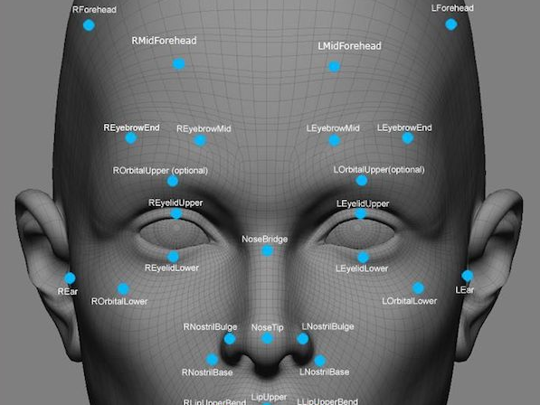

* Establishment of a virtual and physical AR Zone for demonstrations for corporate clients
* Interoperability with future Facebook and Google AR zone and world standards
* Prevention of the ‘overtake’ of humans by AI; or at least prolonging of this effect. Augmentation of human work effort by custom cloud-driven AI and automation via smart contract will allow human minds to focus on more creative or important tasks. Augmentation will provide a multiplier effect and allow humans to remain effective compared to standalone AI for a significant time into the future.